Приложение к технологической карте

№ 1

In the city of Rome there is a street;  
And in that street there is a house;  
And in that house there is a room;  
And in that room there is a desk;  
And in that desk  there is a box;  
And in that box there is a book;  
And in that book there is a letter;  
And in that letter there is a story…

The story  is in the letter,  
The letter is in the book,  
The book is in the desk,  
The desk is in the room,  
The room is in the house,  
The house is in the street,  
The street is in the city of Rome.  
And now you know the story.

№ 2

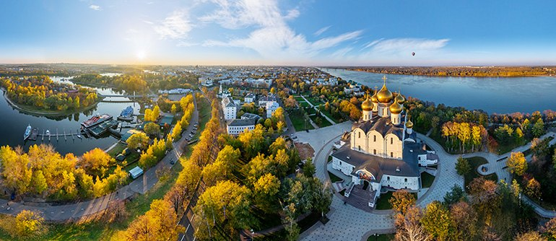

№ 3

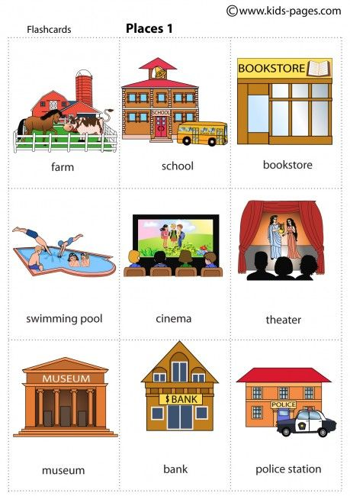

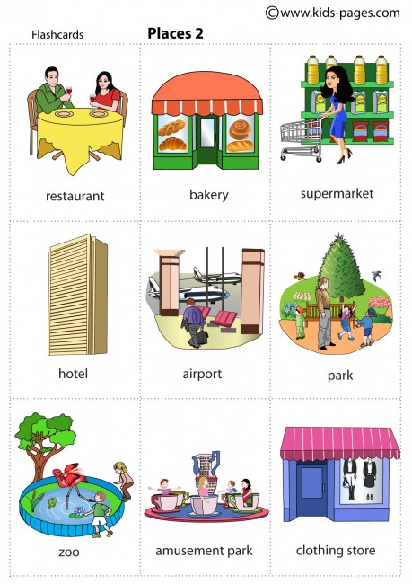

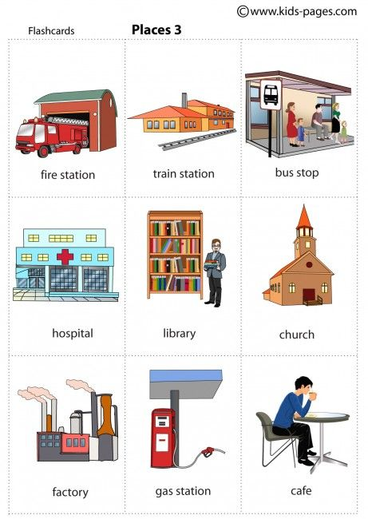

№4

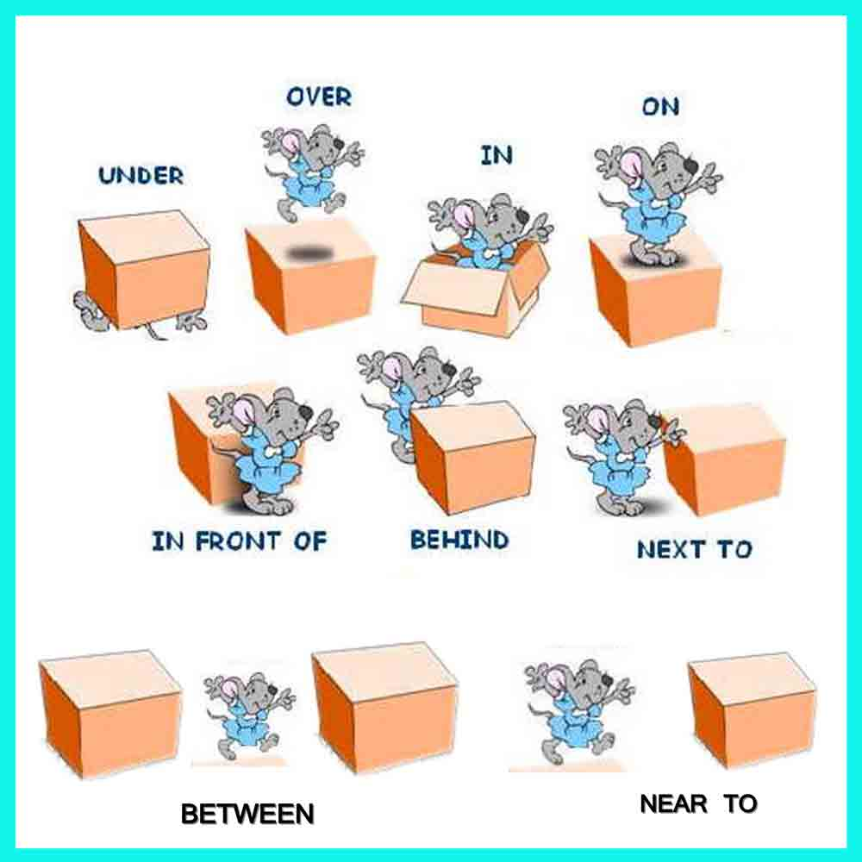

№ 5

|  |  |  |  |
| --- | --- | --- | --- |
| «5»  image_55ca3749968f4.jpg | «4»  416a-vKsreL._SY300_QL70_.jpg | «3»  d51648eafaab785ccd08fca30c4c66e2.jpg | «2»  no-this-person-isnt-crying-use-this-when-youre-disappointed-but-relieved(1).jpg |